# **What is traffic congestion?**

1. Traffic congestion is the result of cities having more drivers than in the past with outdated maintenance, planning, and infrastructure that is not able to handle the needs of public roads.

<https://www.trafficsafetystore.com/blog/4-ways-cities-are-using-smart-technology-to-control-traffic-congestion/>

1. In simple words, congestion occurs when demand for road space exceeds supply.

However, it hasn’t always turned out this way in practice, and the reasons behind could be found in long-term effects of the induced demand. The term “induced demand” refers to the situation where as supply of a good increases, more of that good is consumed. This implies that new roads essentially create additional traffic, which in turn causes them to become congested all over again.

<http://theconversation.com/traffic-congestion-reconsidered-111921>

1. Huston example of induced demand:

<http://cityobservatory.org/reducing-congestion-katy-didnt/>

1. Congestion in transportation facilities—walkways, stairways, roads, busways, railways, etc.—happens when demand for their use exceeds their capacity.

Traffic congestion is now found in cities throughout the world. It continues to increase as the cities’ population and motorization grow and as travel growth outpaces investments in roads and public transportation. The beginning of con- gestion is generally perceived by drivers when their trip time increases by approximately 0.4–0.5 min/mile, and they become acutely aware of congestion when it increases by 0.8–1.0 min/mile. (Falcocchio & Levinson, 2015)

The definition has evolved:

* Mc Clintock in his 1925 book “Street Traffic Control,” defines congestion in street traffic “as a condition resulting from a retardation of movement below that necessary for contemporary streets users” [1].

McClintock M (1925) Street traffic control. McGraw-Hill Book Company Inc, New

* Alan Altshuler [2] indicates that “the term congestion denotes any condition in which demand for a facility exceeds free-flow capacity at maximum design speed”.

Altshuler A, Womack JP, Pucher JR (1979) The urban transportation system—politics and policy innovations. The MIT Press, Cambridge, MA

* Homburger et al. [3]defined congestion as “the level at which transportation system performance is no longer acceptable due to traffic interference. This may vary by type of transportation facility, geographic location, and time of day”.

Homburger WS, Hall JW, Loutzenhouser HC, Reilly W (1996) Fundamentals in traffic engineering. Institute of Transportation Studies, University of California Berkeley, California

* The Institute of Transportation Engineers “Toolbox” (1996) states that “congestion means there are more people trying to use a given transportation facility during a specific period of time than the facility can handle with what are considered acceptable levels of delay or inconvenience” [4].

Meyer MD (1993) A toolbox for alleviating traffic congestion and enhancing mobility. Institute of Transportation Engineers, Washington, DC

* The National Cooperative Highway Research Program Report No. 398 [5, 6] provides a number of definitions of congestion and its correlates of mobility, accessibility, and reliability.

Lisco T, Draft Memorandum to Palewonsky L (1999) RE: AM peak period traffic volumes travel times and speeds on interstate 93. Between Medford and Boston, s.n., 1992–1994 and 1998–1999

Lomax T, Turner S, Shunk G, Levonson HS, Pratt RH, Douglas B (1997) NCHRP 398: quantifying congestion, vol 2. Transportation Research Board, National Research Council, Washington

Traffic congestion reflects the difference between the travel time experienced during busy traffic periods and when the road is lightly traveled. It is also expressed as the ratio of actual travel time and uncongested travel time or the ratio of actual versus uncongested travel time rates (e.g., min/mile). The three basic components of traffic congestion include intensity (amount), extent (area or network coverage), and duration (how long it lasts).

Congestion in cities is a by-product of their success in attracting people to jobs and other amenities, and the inability of cities to improve/expand transportation capacity to keep pace with this growth. The cities’ challenge is to keep congestion manageable as their population and economies grow. To be helpful in congestion management decisions, the definition of congestion should be based on a comparison of “actual travel times” with “expected travel times” for peak hour and off-peak conditions. Expected travel times can vary from area to area, by time of day, and by type of routes, and should be established with the input of the area’s stakeholders (e.g., travelers and freight movers).

(Falcocchio & Levinson, 2015)

1. Freeway congestion delay consists of recurrent delay plus the additional (nonrecurrent) delay caused by accidents, breakdowns, and other random events, such as inclement weather and debris. Recur- rent delay arises from fluctuations in demand, the manner in which the freeway is operated, and the physical layout of the freeway. Non- recurrent delay depends on the nature of the incident: an accident is likely to cause more delay than a vehicle stopped on the shoulder of the highway.

(Skabardonis, Varaiya, & Petty, 2003)

1. Traffic Definition Traffic refers to vehicle movement. This perspective assumes that “travel” means vehicle travel and “trip” means vehicle-trip. It assumes that the primary way to improve transportation system quality is to increased vehicle mileage and speed.

(Litman, 2003)

1. Most fundamentally, we need to determine what traffic congestion is. Second, we need to determine if congestion, per se, is a bad thing. It seems to be taken as axiomatic that it is, but the question has perhaps not been examined very carefully, although there is a notion of optimal congestion in economics that is linked to efficient congestion charges. Third, we need to understand what negative consequences stem from congestion, and whether there are ways to overcome them.

The dictionary defines congestion as an abnormal or excessive accumulation (of traffic, for example). Traffic engineers define congestion as the phenomenon that arises when the input volume exceeds the output capacity of a facility. One implication of congestion is that it represents maximum or excessive use of a facility. Also, as the input volume increases, so the density of traffic increases (density being defined as the number of vehicles per lane per kilometre). As density increases, the speed decreases, because of the proximity of other vehicles.

There are two types of congestion— recurring and non-recurring. The former is the type of congestion that occurs at the same place and the same time day after day, especially on weekdays. The latter is the type of congestion that arises from temporary conditions, such as a vehicle breakdown, accident, or temporary road works. The interest in this paper is with the former—recurrent congestion. The latter, which can largely be regarded as a random event, can be dealt with through various mechanisms, but is not the principal focus of policies that are aimed at congestion reduction.

(Stopher, 2006)

1. Many definitions of congestion:In examining measures of traffic congestion, it is worth exploring the definitions of congestion. The definition of congestion influences what measures are introduced to address it. Many definitions have been proposed to describe traffic congestion on roadways in urban areas. However, there is no universally accepted definition of traffic congestion (Downs, 2004). Table 1 presents a summary of definition of congestion from the research literature. These definitions can be broadly categorized into three groups: (i) demand capacity related, (ii) delay-travel time related, and (iii) cost related.

(Aftabuzzaman, 2007)

1. Transportation has always been a crucial aspect of human civilization, but it is only in the second half of the last century that the phenomenon of traffic congestion has become predominant due to the rapid increase in the number of vehicles and in the transportation demand in virtually all transportation modes. Traffic congestion ap- pears when too many vehicles attempt to use a common transportation infrastructure with limited capacity. In the best case, traffic congestion leads to queueing phenomena (and corresponding delays) while the infrastructure capacity (“the server”) is fully utilized. In the worst (and far more typical) case, traffic congestion leads to a degraded use of the available infrastructure (reduced throughput), thus contributing to an accelerated congestion increase, which leads to further infrastructure degradation, and so forth. Traffic congestion results in excess delays, reduced safety, and increased environmental pollution.

(Diakaki, Kotsialos, & Wang, 2003)

1. Past definition of congestion can be focused on causes or in effects

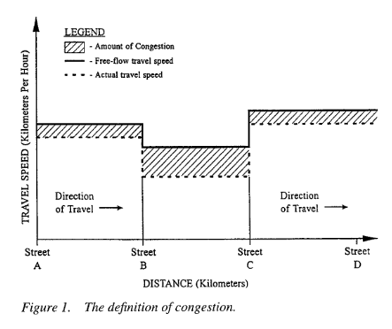

(Lomax, 1997)

1. The word “congestion” is frequently employed in the road traffic context, both by technicians and by the public at large. Webster’s Third New International Dictionary defines it as “a condition of overcrowding or overburdening”, while “to congest” means “to overcrowd, overburden or fill to excess so as to obstruct or hinder” something: in this case, road traffic. It is usually understood as meaning a situation in which there are a large number of vehicles circulating, all of which are moving forward in a slow and irregular manner. These definitions are of a subjective nature, however, and are not sufficiently precise.

Without going into such detail, yet continuing to seek objectivity, the term congestion could be defined as “the situation which occurs if the introduction of a vehicle into a traffic flow increases the travel times of the other vehicles by more than x%”. An objective although still somewhat arbitrary definition of congestion would be to define it as the volume of traffic at which d(qt)/dq = at, where a equals, for example, 1.50. In other words, congestion would begin when the increase in the journey time of all the vehicles already present in the flow was equal to half of the travel time of an additional vehicle.

(Bull, 2004)

1. to discuss current definitions of metropolitan traffic congestion and ways it is currently measured. In addition, the accuracy and reliability of these measures will be described along with a review of how congestion has been changing over the past several decades.

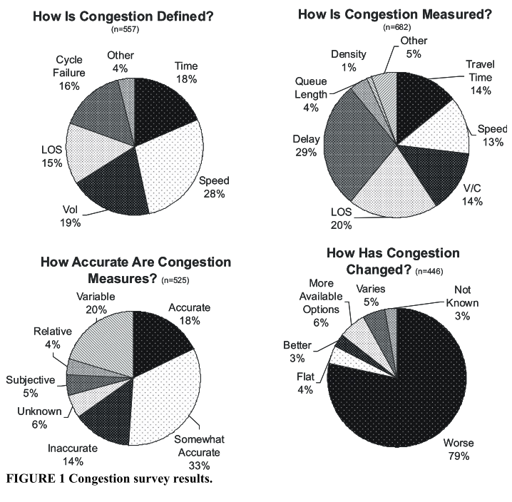

"Congestion is people with the economic means to act on their social and economic interests getting in the way of other people with the means to act on theirs!" (26) This section mentions a few important points that should be considered when thinking about congestion. It is generally felt that congestion on the nation’s highway system continues to increase, both in reality and in people’s perceptions.

In order to reliably estimate how congestion affects different travelers we need three

things. First we have to know who is on the congested highway links and how and why they’re traveling. Second we need to understand the trip characteristics that are important to travelers (e.g., travel time, reliability). Third, we need data that can be used to estimate these important trip characteristics.

(Bertini, 2005)

1. NEED FOR NEW MEASURES

Currently, there are several collaborative efforts from private companies, government agencies, and research community to collect traffic data from major roads and report traffic condition to the public. In our study, we found that most of these efforts are focused on the installation of fixed sensors, such as intelligent video cameras with image pro- cessing capability and inductive loops. Although, these sensor infrastructures will provide accurate traffic information, very limited number of roads are equipped with them due to their high initial and maintenance costs. Clearly, an alternate way to collect traffic data at a lower cost with wider coverage and better flexibility is needed.

Estimating road traffic congestion from cell dwell time using neural network

Reporting road traffic congestion can be a confusing task since there is no standard way of measuring congestion. Typical users need a concise and easy-to-understand traffic report. One of the popular methods used is to report road congestion by severity levels.

(Pongpaibool, Tangamchit, & Noodwong, 2007)

1. Congestion to the traveler is immobility. It is long lines of stopped or slowly moving vehicles on a freeway, suburban highway, or city street. It is the traffic “backups” on the approach to an open draw- bridge, at a bottleneck or choke point on the street system, or at a freeway lane drop as a result of design, accidents, or construction. Traffic congestion usually results when (a) the road system is unable to accommodate traffic at an adequate speed, (b) there are conflicts among the different types of traffic (cars, trucks, buses, or pedestrians), or (c) traffic controls are improperly used. Often, these problems work together to create or increase congestion. Table 1 gives examples of congestion resulting from these deficiencies. Congestion manifests itself over both time and space. It may occur along short or long sections of roadway; it may occur for a few minutes, a few hours, or the entire day. Conceptually, it can be viewed as a series of contours (Figure 1) that define its geographic extent, duration, and intensity. These contours are similar to the freeway density contours (vehicles per lane per kilometer) that have been used to define freeway performance and problems. • Congestion is travel time or delay in excess of that normally incurred under light or free-flow travel conditions (Figure 2). • Unacceptable congestion is travel time or delay in excess of an agreed-upon norm. The agreed-upon norm may vary by type of transportation facility, geographic location, and time of day.

(Levinson & Lomax, 1997)

1. Many measures have been proposed to represent the status of traffic conditions on arterial roadways in urban areas. The debate about what is the most appropriate measure continues. In a contribution to the debate, another approach was offered. Traditionally, two general approaches exist. One is based on the relationship between supply and demand. The other is a measure relative to the most acceptable status of service quality. The latter measure allows the public to relate to their travel experience.

Traffic congestion is an unavoidable part of modern-day life. To understand the nature of congestion and to control its growth, a system for measuring the severity of traffic congestion is needed. Such a measure provides the foundation for traffic engineers and policy makers to identify problems and determines the effectiveness of mitigation strategies. In addition, a consistent and uniform measure will allow comparison of traffic conditions at different locations and also over time at the same location so that priorities for improvements can be developed, which helps the public to understand the traffic conditions objectively

(Hamad & Kikuchi, 2002)

# **Accessibility? Or Congestion?**

1. Accessibility is a concept used in transport planning, urban planning, and geography. It may be generally defined as possibilities to do things at different places. People in areas with a high level of accessibility will be more productive and possibly happier than people in more remote and isolated areas. The task of transport is to enable such spatial interaction. For the development of transport policy it is important to study accessibility effectively from several different angles. However, accessibility is often a rather abstract concept for policy makers. Handy and Niemeier (1997) identify a gap between the academic literature and the practical application of accessibility measures. This paper aims to partly fill this gap by developing a measure of accessibility changes over time, to be used in policy making. The goal of the paper is twofold. First we aim to present the indicator, including a practical application. Secondly, we reflect on it: What are its strong and weak points?

* To reflect on> Who is affected? The indicator does not tell anything about space!

(Koopmans, Groot, Warffemius, Anne, & Hoogendoorn-lanser, 2013)

1. Accessibility (or just access) refers to the ability to reach desired goods, services, activities and destinations (collectively called opportunities).3, 4 Access is the ultimate goal of most transportation, except a small portion of travel in which movement is an end in itself (jogging, horseback riding, pleasure drives), with no destination. This perspective assumes that there may be many ways of improving transportation, including improved mobility, improved land use accessibility (which reduce the distance between destinations), or improved mobility substitutes such as telecommunications or delivery services.(Litman, 2003)
2. Accessibility can be defined as the ease of reaching destinations (Levine and Garb, 2002), whereas mobility may be defined as the ease of movement. While these two concepts are clearly related, they are not the same thing. If a person lives in an area where there are many possible destinations close by, accessibility may be very high, even though mobility might be constrained, as in a CBD. On the other hand, if a person lives in a relatively remote area, accessibility may be poor because considerable travel time and cost is required to reach any destination, although mobility may be high. In 1960, world inhabitants travelled an average of 1820 km by car, bus, railway or aircraft. Three decades later, the annual distance travelled had increased to 4390 km. In light of a 75% world population growth, absolute motorised mobility rose by a factor greater than four (Schafer, 1998).

(Stopher, 2006)

1. Are we capturing accessibly or congestion In a work to map accessibility something similar is usually done?

This paper compares the spatial structure of car accessibility to towns and to railway stations during peak and off-peak hours in Belgium for the country’s 2616 municipalities. A clustering method is applied. It is shown that in a highly urbanized country, the situation is far from being spatially equitable in terms of accessibility, and some areas are more favored than others. Congestion increases spatial inequalities, differently according to absolute or relative measures of change.

(Vandenbulcke, Steenberghen, & Thomas, 2012)

1. By way of conclusion, we suggest Accessibility Planning can and does address what ‘matters’ (both to individuals and planners) but the measures used to assess and evaluate accessibility changes do not necessarily relate to the desired outcomes and may actually be counter-productive in achieving the kind of change that matters, or delivers real improvements in accessibility where it is needed. The process of Accessibility Planning has been useful in raising the profile of accessibility and social exclusion related issues within local authorities, although in many cases the work was already being undertaken, albeit under a different label. Nevertheless, it has helped officers to highlight the importance of this kind of work at a corporate and strategic level, as well as with stakeholders. While the work will continue without the formal process of Accessibility Planning it might be harder for planners to justify the need for this and give importance to accessibility-related improvements.

(Curl, Nelson, & Anable, 2011)

1. Accessibility, the ease of reaching destinations, is a key land use and transportation performance measure (Wachs and Kumagai, 1973). It is increasingly used by researchers to spatially assess the joint benefits provided by the transportation network and the land use system in a region (Huang and Wei, 2002; Kawabata and Shen, 2007; Bocarejo and Oviedo, 2012; Manaugh and El-Geneidy, 2012) and to identify spatial gaps in access to opportunities (Paez et al., 2010b, 2010a). Under- standing and visualizing accessibility patterns and changes across a region contributes to developing spatially targeted land use and trans- portation interventions. While accessibility has been extensively researched with the ultimate purpose of informing decision-making and influencing land use and transportation planning, little is known on the use of accessibility metrics in transportation practice. In fact, although transportation issues are increasingly framed in terms of access to op- portunities (Preston and Rajé, 2007; Handy, 2008; Geurs et al., 2012; Lucas, 2012; Manaugh et al., 2015), accessibility is still largely mar- ginalized in practice (Levinson and Gillen, 2005; Halden, 2011; Proffitt et al., 2015).

While 90% of the respondents are familiar with the concept, only 55% stated that they use accessibility metrics in their work. Whereas lack of support and interest does not appear to be a major obstacle to using accessibility metrics, lack of knowledge and data are highlighted as the main barriers to the use of metrics in practice. These results suggest that further training and collaboration is required to support the use of metrics by practitioners. Furthermore, including clear accessibility indicators in planning documents is key to promoting the use of metrics in policy and practice, as it was stated as a main reason motivating the generation of accessibility metrics. This research highlights potential avenues to support the integration of accessibility metrics in practice and is of relevance to researchers, planners and policy-makers wishing to foster accessibility-based planning approaches.

(Boisjoly & El-geneidy, 2017)

# **Why traffic congestion happens?**

1. Parking as a congestion producer and time waster

<http://inrix.com/press-releases/cod-us/>

1. Huston example of induced demand:

<http://cityobservatory.org/reducing-congestion-katy-didnt/>

1. Uk car dependency increases

<https://www.smartcitiesworld.net/news/uk-car-dependency-increases-3364>

For a summary of the causes of congestion: Concentration of Trips in Space and Time, Growth in Population, Employment, Car Use and Insufficient Capacity, Bottlenecks.

(Falcocchio & Levinson, 2015)

1. Part of the reason for this situation is that transport users do not always cover the costs they generate. Indeed, the price structure generally fails to reflect all the costs of infrastructure, congestion, environmental damage and accidents. This is also the result of the poor organization of Europe’s transport system and failure to make optimum use of means of transport and new technologies.

(European Commission, 2001)

1. The fundamental law of road congestion: Evidence from US cities.

Demand side policies such as road expansion and new roads will follow this law.

(Duranton & Turner, 2011)

1. Most transport analysts subscribe to the application of economic theory to travel, from which, it is generally held that travel is a derived demand, i.e. that people do not generally travel for the sake of travelling, but rather to reach some location where they can pursue an activity

(Stopher, 2006)

1. Is it because city size? City size, network structure and traffic congestion. The findings reinforce the ‘compact city’ hypothesis, by favoring a larger mixed-use core area with greater zone width, block density and number of lanes, compared to the peripheral area. They also suggest a new set of policies, including the optimization of perimeter controls and the fraction of land for transport, which constitute robust second-best optimal strategies that can further reduce congestion externalities.

(Tsekeris & Vogiatzoglou, 2011)

1. Lack of information and coordination: Highly theoretical mathematical computational approach to show results of non-cooperative games

(Gairing, 2005)

1. MODELLING AND VALIDATING TRAFFIC FLOWS: TIME OF OCCURENCE

Later, using real data from detectors for an urban arterial and a free- way network we validate the proposed derivations and we show that an MFD is not well defined in freeway networks as hysteresis effects are present. The datasets in this paper consist of flow and occupancy measures from 500 fixed sensors in the Yokohama down- town area in Japan and 600 loop detectors in the Twin Cities Metropolitan Area Freeway network in Minnesota, USA.

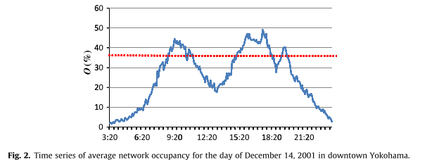

(Geroliminis & Sun, 2011)

1. Also to back up when congestion happens see

(Soylemezgiller, Kuscu, & Kilinc, 2013)

1. Land use and job market connection to congestion. Poor land use planning can determine poor transport performance

(Sultana, 2013)(Acheampong & Silva, 2015; Brandi, Gori, Nigro, & Petrelli, 2014; Miller & Salvini, 2001; Sultana, 2013)

1. Infrastructure and traffic. Model in Japan to understand changes in design.

(Mehran & Nakamura, 2009)

# **What are the consequences associated with congestion?**

1. Parking as a congestion producer and time waster

<http://inrix.com/press-releases/cod-us/>

1. Pollution in Europe due to congestion

<https://www.citylab.com/transportation/2016/09/london-has-europes-worst-congestions-says-a-new-study/499640/>

1. "Though the total carbon emissions are still on a rising trend, the three cities have already achieved some emission reduction results compared with the business-as-usual scenario. Reductions have reached 0.95, 1.53 and 0.98 million tons in Suzhou, Chengdu and Harbin respectively."

<https://www.worldbank.org/en/news/feature/2018/11/16/reducing-traffic-congestion-and-emission-in-chinese-cities>

1. Inrix calculated the economic cost of congestion across the US, UK and Germany at almost $461 billion in 2017 or $975 per capita. And there is another critical issue at stake: pollutants in vehicle emissions contribute to poorer air quality and premature deaths in cities around the world.

<https://www.smartcitiesworld.net/special-reports/special-reports/traffic-congestion-cutting-through-the-complexity>

1. List of consequences:

* Reduced Productivity
* Reduced Emergency Assistance
* Noise Pollution
* Increased Accidents
* Air Pollution

<https://www.trafficsafetystore.com/blog/4-ways-cities-are-using-smart-technology-to-control-traffic-congestion/>

1. List of consequences:

* Fuel Consumption & Pollution
* Road Rage
* Emergency Vehicles

<https://traveltips.usatoday.com/effects-traffic-congestion-61043.html>

1. In (Falcocchio & Levinson, 2015) there is a description of the consequences of Congestion.

Transport is crucial for our economic competitiveness and commercial, economic and cultural exchanges. This sector of the economy accounts for some _1000 billion, or over 10 % of the EU’s gross domestic product, and employs 10 million people. Transport also helps to bring Europe’s citizens closer together, and the Common Transport Policy is one of the cornerstones of the building of Europe. However, the warning signs are clear. Congestion, resulting in environmental nuisance and accidents, is getting worse day by day, and penalizing both users and the economy. If nothing is done, the cost of congestion will, on its own, account for 1 % of the EU’s gross domestic product in 2010 while, paradoxically, the outermost regions remain poorly connected to the central markets.

(Falcocchio & Levinson, 2015)

1. Because of congestion, there is a serious risk that Europe will lose economic competitiveness. The most recent study on the subject showed that the external costs of road traffic congestion alone amount to 0.5 % of Community GDP. Traffic forecasts for the next 10 years show that if nothing is done, road congestion will increase significantly by 2010.The costs attributable to congestion will also increase by 142 % to reach EUR 80 billion a year, which is approximately 1 % of Community GDP.

(European Commission, 2001)

1. Environment Birds affected by noise pollution

(Halfwerk, Holleman, Lessells, & Slabbekoorn, 2011)

1. Financial consequences of congestion

We show this quantity versus population in Figure 2 and we observe a significant increase

of this financial loss with population from less than 1% to almost 10% of the GDP. Asian cities have a larger loss (on average 4%) followed by the other regions which have roughly the same level (of order 1–2%).

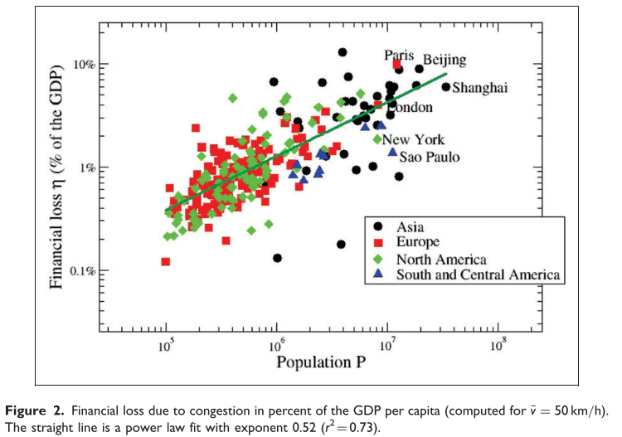

We thus have contradictory results with respect to density which has an unclear role and his shows that our theoretical understanding of congestion at the urban level, at least, is incomplete. We need more measures and also new theoretical insights in order to understand the impact of density on congestion, pollution and gasoline consumption. When facing this puzzle, it seems difficult to provide to urban planners and policy makers with good scientific advice which is grounded in observation and theory. However, we understand here that there are at least two factors which play a major role.

(Barthelemy, 2016)

1. Review of congestion costs also can be found in

(Litman, n.d.)

1. Also for traffic externalities

(Stopher, 2006)

1. Detail costing from TEXAS Urban Mobility REPORT

The trends from 1982 to 2017 show that congestion is a persistently growing problem. The problem is larger than ever. In 2017, congestion caused urban Americans to travel an extra 8.8 billion hours and purchase an extra 3.3 billion gallons of fuel for a congestion cost of $166 billion.

Trucks account for $20 billion (11 percent) of the cost, a bigger share than their 7 percent of traffic. The average auto commuter spends 54 hours in congestion and wastes 21 gallons of fuel due to congestion at a cost of $1,080 in wasted time and fuel.

(The Texas A&M Transportation Institute, 2019)

1. Poor air quality due to congestion

(Kelly & Zhu, 2016)

1. Congestion, business development and productivity

(Ewing, 1997; Gerritse & Arribas-Bel, 2018; Glaeser, 2011; Sweet, 2011; Weisbrod, Vary, & Treyz, 2003)

1. Throughout the world, traffic congestion reduces the core benefit of cities: the ability to connect with other people easily

(Glaeser, 2011; Hymel, Small, & Dender, 2010)

1. Traffic congestion is a major urban transportation problem (Downs, 1992; Litman, 2004). Different researchers have provided alternative definitions of traffic congestion. However, there is no universally accepted definition of traffic congestion (Downs, 2004). Many measures have been developed to represent the magnitude of traffic congestion on roadways in urban areas. But there is a debate about what is the most appropriate measure of traffic congestion (Lomax et al, 1997).

(Aftabuzzaman, 2007)

1. Across the European Communities as a whole, it has recently been estimated that the total economic loss through urban and interurban congestion and de- tours amounts to 500 billion European Currency Units (ECU) per year. Around 55,000 people are killed on Community roads and 1.7 million are injured; and the contribution of vehicle emissions to environmental pollution (excluding the contribution to global warming) is estimated to cost the Community between 5 and 10 billion ECU per year (Bielefeldt, 1989). These figures are projected to increase substantially.

(Jones & Hervik, 1992)

1. The congestion cost is computed through the aggregation of the opportunity cost of people waiting within the transport system, as a consequence of traffic congestion. Monte Carlo experiments produced an approximated congestion cost of US$1.02 million during a typical working day. Moreover, the simulation provides useful information about the average traveling time for the 14 districts of the city.

(Garrido, 2012)

1. Links of pollution and economic lose search for a page in

(Sutton, 2015)

1. Relation with traffic safety

(Quddus, Wang, & Ison, 2010; Stempfel, Guler, Menéndez, & Brucks, 2016; C. Wang, Quddus, & Ison, 2013)

1. Poor air quality and noise

(Wardman & Bristow, 2004)

1. Traffic congestion has been increasing in much of the world, developed or not, and everything indicates that it will continue to get worse, representing an undoubted menace to the quality of urban life. Its main expression is a progressive reduction in traffic speeds, resulting in increases in journey times, fuel consumption, other operating costs and environmental pollution, as compared with an uninterrupted traffic flow.

Congestion is mainly due to the intensive use of automobiles, whose ownership has spread massively in Latin America in recent decades. Private cars have advantages in terms of facilitating personal mobility, and they give a sensation of security and even of heightened status, especially in developing countries. They are not an efficient means of passenger transport, however, since on average at rush hours each occupant of a private car causes about 11 times as much congestion as a passenger on a bus. The situation is further aggravated in the region by problems of road design and maintenance in the cities, a style of driving which shows little respect for other road users, faulty information on traffic conditions, and unsuitable management by the responsible authorities, which are often split up among a host of different bodies. The cost of congestion is extremely high. According to conservative calculations, for example, increasing the average speed of private car journeys by 1 km/hr and that of public transport by 0.5 km/hr would give a reduction in journey times and operating costs worth the equivalent of 0.1% of the gross domestic product (GDP) (Thomson, 2000b).

(Bull, 2004)

1. Well-being and congestion. Congestion and travel time.

Usin ordinary least squares and logit regression models, commute time was found to be statistically significant and negatively related to both the global evaluation of SWB and the experientially focused measure of SWB. Because this study used 4 years of well-being data from the United States, these results provide robust support that commute time does have a significant role in well-being in the United States. The analysis also found a strong correlation between commute time and congestion, a finding which suggests that effective policies to reduce congestion can be one method to improve SWB for large populations

(Choi, Coughlin, & Ambrosio, 2013)

1. We find that while in aggregate network effects are not significant, congestion measured on a single link is a poor predictor of total congestion costs imposed by travel on that link. Also, we analyze the congestion proliferation effect on the network to see how congestion is distributed within an urban area

Do networks matter?

(Safirova, Gillingham, & Houde, 2007)

# **How cities address congestion?**

**GOTHENBURG**

* <http://roadpricing.blogspot.com/2013/01/gothenburg-introduces-congestion.html>

**LONDON**

* In 2003, London implemented a Congestion Charging fee. The city is still underperforming.
* London cars may now be moving “slower than a horse and cart” but that doesn’t necessarily mean the congestion charge was a failure. <https://www.citylab.com/solutions/2016/10/traffic-in-london-is-out-of-control-what-happened/505454/>
* Is London running out of roads? <https://www.ft.com/content/40774fc6-76b5-11e6-bf48-b372cdb1043a>

**SINGAPORE**

* Car ownership is controlled through quota system introduced in 1990s. Car buyers bid for Certificate of Entitlement (COE) – the right to car ownership and usage of road space. Its cost is determined by demand and supply for vehicles, meaning that if demand is high, COE could become more expensive than the car itself. However, this measure showed some limitations. Many people felt that as long as they are paying such a high cost for driving, they should use their car as much as possible – hence the traffic congestion worsened. <http://theconversation.com/traffic-congestion-reconsidered-111921>

**NEW YORK**

* Following the example of London, in 2021 New York will become the first US city to implement congestion pricing for select zones of Manhattan. The measure has been long discussed and disputed, with various proposals surfacing and dying regularly over the last 10 years. Why? Congestion charges are politically challenging to undertake, to say the least. <http://theconversation.com/traffic-congestion-reconsidered-111921>
* In the case of New York, congestion charging is intended to address several worrying indicators. As of 2018, average car speed has fallen to 4.7 mph, which is only slightly faster than walking.

**LOUISVILLE**

* The data and the traffic cam photos suggest that Louisville has demonstrated a powerful, fast-acting solution for reducing traffic congestion: charge a toll. It’s too bad they found out only after spending in excess of a billion dollars building new road capacity that apparently wasn’t needed or valued by those who travel across the Ohio River each day. Maybe other cities can learn from the Louisville’s expensive experiment.

**SUZHOU, CHENGDU & HARBIN (CHINA)**

<https://www.worldbank.org/en/news/feature/2018/11/16/reducing-traffic-congestion-and-emission-in-chinese-cities>

**CONGESTION FEE DEBATE**

<https://www.autonews.com/shift/fee-zones-cities-ease-traffic-congestion-spark-controversy>

**NORTHERN VIRGINIA**

* Northern Virginia in the US, meanwhile, consistently ranks as one of the most congested areas in the country. Because building new roads or expanding highways isn’t possible, it wanted to reduce travel demand and has been tapping into data supplied by mobility metrics specialists Streetlight Data since 2015.

Northern Virginia has been able to scan hundreds of congested road segments at different times and types of day to identify those with the highest volume of short trips and the most trips between specific origins and destinations. These segments can then be targeted for transportation demand management tactics such as bike lanes and other transit options.

"This data helped us understand the likely effects of 24 projects that were under consideration," said Keith Jasper, programme coordinator, Northern Virginia Transportation Authority. "The origin-destination information was incredibly useful for understanding behavior in and between activity areas."

<https://www.smartcitiesworld.net/special-reports/special-reports/traffic-congestion-cutting-through-the-complexity>

<https://www.smartcitiesworld.net/news/virginia-taps-into-traffic-intelligence-2509>

**LA TUNNEL**

* <https://edition.cnn.com/2018/12/19/tech/boring-company-tunnel-elon-musk/index.html>

**MILAN Congestion charge**

* (Percoco, 2014)

# What are strategies to address/solve congestion?

1. **Drones delivery**

* <https://www.ericsson.com/en/blog/2018/6/we-need-three-dimensional-traffic-congestion-solutions>

1. [**https://www.gokid.mobi/four-ways-we-can-solve-city-traffic/**](https://www.gokid.mobi/four-ways-we-can-solve-city-traffic/)

* Ride Sharing and Ride Hailing Apps
* Implementing Adaptive Traffic Signals
* Drones to the Rescue?
* Carpooling

1. [**https://www.trafficsafetystore.com/blog/4-ways-cities-are-using-smart-technology-to-control-traffic-congestion/**](https://www.trafficsafetystore.com/blog/4-ways-cities-are-using-smart-technology-to-control-traffic-congestion/)

* Adaptive Traffic Signals
* Real-Time Traffic Monitoring
* Cities Turning to IoT To Help Solve Traffic Congestion

1. **Smart Corridors**

* <https://statetechmagazine.com/article/2017/09/smart-technology-makes-managing-traffic-breeze-transportation-departments>

1. For theoretical policy recommendations there are some mathematical models developed: BUMPS, LOW EMSSION ZONES AND BYPASES in

(Borger & Proost, 2013)

1. Debate over when congestion fees are good or not

(Anas & Rhee, 2007; Andersson & Nässén, 2016; Hysing, Frändberg, & Vilhelmson, 2015; Percoco, 2014; Rouwendal, Verhoef, & Knockaert, 2012)

1. Less density? Suburbanization?

Suburbanization has been the dominant and successful mechanism for reducing congestion. It has shifted road and highway demand to less congested routes and away from core areas. All of the available recent data from national surveys on self-reported trip lengths and/or durations corroborate this view. The findings from all seven recent large-scale national household surveys present a consistent story of the containment of metropolitan area commuting times

(Gordon and Richardson 1994b). (Gordon & Richardson, 1997)

1. A review of strategies to reduce congestion can be found in :

(Bull, 2004; Diakaki et al., 2003)

1. Ring roads to alleviate congestion in the long run?

(Nugmanova, Arndt, Hossain, & Kim, 2019)

1. Extensive review of practices can be found in

(Santos, Behrendt, & Teytelboym, 2010)

# **What is the connection with the SDG?**

1. "Though the total carbon emissions are still on a rising trend, the three cities have already achieved some emission reduction results compared with the business-as-usual scenario. Reductions have reached 0.95, 1.53 and 0.98 million tons in Suzhou, Chengdu and Harbin respectively."

<https://www.worldbank.org/en/news/feature/2018/11/16/reducing-traffic-congestion-and-emission-in-chinese-cities>

1. ‘Green cities’ combine higher levels of efficiency, with innovative capacity and reduced environmental impact, addressing issues like congestion through the implementation of, among others, road charges and integrated public transport systems. This ‘greening’ of cities has the potential to reduce pollution and the harm that may be done to an individual’s health, for example, by reducing traffic, promoting the use of cleaner or renewable fuels, encouraging cyclists/pedestrians, or introducing more green spaces (see Chapter 6).

Urban areas are often characterized by their high concentrations of population, economic activity, employment and wealth with the daily flow of commuters into many of Europe’s largest cities suggesting that opportunities abound in these hubs of innovation, distribution and consumption, many of which act as focal points within their national economies and in some cases within Europe or even globally.

Although cities are motors for economic growth, they are also confronted by a wide range of problems, like crime, traffic congestion, pollution and various social inequalities. Furthermore, within many cities it is possible to find people who enjoy a comfortable lifestyle living in close proximity to others who may face considerable challenges, for example, in relation to affordable/adequate housing or poverty — herein lies the ‘urban paradox’.

(Eurostat, 2016)

1. Welfare loss due to congestion: Congestion costs are broken down into different categories and estimated. A debatable, but generalizable methodology can be used to asses other cities or towns.

(Bilbao-ubillos, 2008)

1. The United Nations declared that one-half of humanity was living in cities in 2008 and that the world’s urban population would increase by another 50%, to 5 billion, by 2030 (1). The tight correlation between urbanization and economic development led me to depict this trend optimistically in my recent book, Triumph of the City (2): that the growth of cities reflects a global transition from poverty to prosperity. But urban density also brings enormous challenges, including crime, congestion, and contagious disease, and these challenges are being poorly met by many of the world’s weaker governments.

Throughout the world, traffic congestion reduces the core benefit of cities: the ability to connect with other people easily

(Glaeser, 2011)

1. The modelling of scenarios for public policy

(Aftabuzzaman, Currie, & Sarvi, 2010)

1. in European Conference of Ministers of Transport (ECMT, 1990). These include:

1. Traffic congestion (resulting in longer and less predictable journey times);

2. Traffic accidents/road safety; 3. Traffic noise; 4. Vehicle pollution; 5. Carbon dioxide emissions and global warming; 6. The colonization of various public spaces by illegally parked cars;7.Severance of social networks; and 8. The general unpleasantness of using street spaces on foot.

(Jones & Hervik, 1992)

1. One of the big problems facing city municipalities is the traffic congestion. It makes life in cities uncomfortable for people. Every year governments spend huge budgets to solve this problem.

(Muhammad Ali & Faraj, 2013)

1. Road traffic and violence and stress (Hennessy & Wiesenthal, 1999)
2. Traffic congestion in urban areas is an increasingly severe problem for major cities. Estimating historic, current and prospective traffic is crucial to take measures against traffic jams in road networks. The quick spread of mobile traffic sensors allows to gather network-wide traffic data und thus, allows to analyze traffic congestion on a wider scale and in more detail than it has been possible before.

(Rempe, Huber, & Bogenberger, 2016)

1. Congestion—both in perception and in reality—impacts the movement of people and freight and is deeply tied to our history of high levels of accessibility and mobility. Traffic congestion wastes time and energy, causes pollution and stress, decreases productivity and imposes costs on society equal to 2-3% of our gross domestic product (GDP) (2). For 2002, it was estimated that congestion “wasted” $63.2 billion in 75 metropolitan areas because of extra time lost and fuel consumed, or $829 per person. (3) Some refer to these estimates as misleading since the prospect of eliminating all congestion is “only a myth; congestion could never be eliminated completely.” (4).

(Bertini, 2005)

# **How congestion is being measured? Who measures congestion?**

1. VISUAL REPRSENTATION:

(Cruz & Machado, 2011)

1. CONGESTION MEASURMENT IN FREEWAY:

(Skabardonis et al., 2003)

1. USING SOCIAL MEDIA: This paper proposes an alternative solution with lower cost and wider spatial coverage by exploring traffic related in- formation from Twitter. By regarding each Twitter user as a traffic monitoring sensor, various real-time traffic information can be collected freely from each corner of the city. However, there are two major challenges for this problem. Firstly, the congestion related information extracted directly from real-time tweets are very sparse due both to the low resolution of geographic location mentioned in the tweets and the inherent sparsity nature of Twitter data. Secondly, the traffic event information coming from Twitter can be multi-typed including congestion, accident, road construction, etc. It is non-trivial to model the potential impacts of diverse traffic events on traffic congestion.

(S. Wang, He, Stenneth, Yu, & Li, 2015)

1. USING CAMERA

(Downs, n.d.; Li, Chen, Huang, & Huang, 2008; Porikli & Li, 2004)

1. For a review of different methods:

(Aftabuzzaman, 2007)

1. How to define congestion and a set of metrics can be found in LOMAX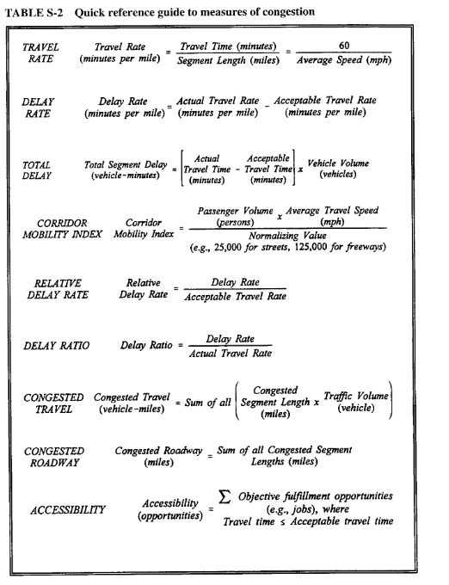

(Lomax, 1997)

1. However, monitoring an entire traffic network and providing forecasts for any possible location is very costly and, since significant parts of the network are never congested, also not necessary. This is also the fundamental motivation for the proposed approach: Start with identifying areas in which connected pockets of congestion typically emerge and reside, and then analyze primarily them instead of the whole road network. These congestion-prone areas will from here on be denoted as congestion clusters. The hope is that congestion clusters can be understood as "neuralgic points" of the network. As such, they are most relevant to drivers and traffic management and possibly allow drawing conclusions on the traffic status of the whole network. The paper is structured as follows: First, an overview on literature concerning urban traffic analysis and forecast will be provided. Then, the Floating Car (FC) data that are used to identify congestion clusters and the data preparation process are described. In a next step, it is explained which properties congestion clusters should show and how they can be computed algorithmically. Finally, a case study is executed. Munich (Germany) and its suburbs are used as test site for a five months period. The sensitivity of the cluster computation methodology on its input parameters is discussed. Then, the congestion in the clusters is analyzed. First focus is laid on the typical congestion starts and ends, and second, the correlation between pairs of clusters is determined.

(Rempe et al., 2016)

1. Using cellphones:

This process of changing association from one base station to another is called handoff. CDT is the duration that the phone remains registered to a base station before a handoff occurs. A high CDT value indicates that the phone remains within a cell for a long period of time. If the phone is inside a moving vehicle, we can therefore reasonably deduce that a long CDT also indicates long travel time and hence, congested traffic.

(Pattara-Atikom & Peachavanish, 2007)

1. The other two measures of congestion reflect travelers’ perception of the quality of flow. They measure the quality of flow relative to an ideal or acceptable condition. Hence, they indicate the condition of flow that travelers can relate to their travel experience. The first is relative delay rate, developed by Lomax et al. (1), and the second is the congestion index developed by D’Este et al. (6) and Taylor (7 ).

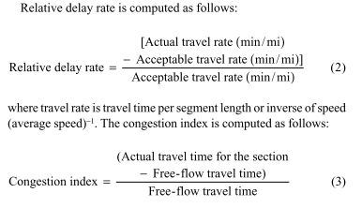

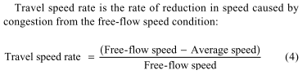

(Hamad & Kikuchi, 2002)

# Critiques of measures? And political agenda behind indexes

1. Against INDRIX

<http://cityobservatory.org/why-the-new-inrix-traffic-scorecard-deserves-a-d/>

<http://cityobservatory.org/cappuccino-congestion-index/>

1. The INRIX report only says, “The 2018 Global Traffic Scorecard not only analyzes time lost, but also the severity of congestion.” Yet I don’t find any measures of “severity” anywhere in the report.

<https://www.newgeography.com/content/006242-inrix-2018-congestion-scorecard>

1. Methodological concerns

<http://cityobservatory.org/the-top-ten-reasons-to-ignore-ttis-urban-mobility-report/>

1. Critique to Mobility Measures and a Synthesis included in the Urban Mobility Report (UMR) produced annually by the Texas Transportation Institute and widely used to gauge metropolitan traffic problems has overlooked the role that variations in travel distances play in driving urban transportation problems.

These problems are identified:

Baseline for Congestion Costs

Travel Time Index and Distance Variations

Modeled vs. Actual Speeds

The Travel Time Index constitutes an unreasonable baseline, it ignores variations in distances traveled among metropolitan areas, and it overestimates the effect of congestion on travel times. The UMR methodology also overestimates fuel use associated with congestion.

Despite its weaknesses, the Urban Mobility Report aims to answer an important set of questions: How well is the nation’s urban transportation system working? What are the costs resulting from that system’s shortcomings and how are various metropolitan areas performing?

Just as troubling from a policy standpoint is the construction of the “Travel Time Index” as a measure of urban transportation system performance. It sets an unrealistic baseline—that no travel should take place in congested conditions—and its construction, as a ratio measure, penalizes cities with shorter travel distances. And the measure totally obscures from view the effect of land use on travel times and travel costs.

(Joe Cortright, 2010)

1. Reports on congestion focus on specific places; segments of a road. But there is almost no information regarding who is affected by what

(Kansas City Scout, 2011).

1. Also, aggregation to national level or city level produces no insights for policy makers or planners

(Cookson & Pishue, 2016; HERE, 2019; Reed & Kidd, 2019; Tom Tom, 2012; TomTom, 2019)

1. The urban mobility report does not provide a single map. How can planners or local authorities deal with this issue? It needs to be spatialized. Demand side policies have proven to fail, resources should then be allocated to other policies.

(The Texas A&M Transportation Institute, 2019)

1. How to asses a congestion metric: Considering the different desirable attributes for a congestion measure suggested by the afore-mentioned researchers, the congestion measures in the subsequent sections will be assessed using the following criteria. • demonstrates clarity and simplicity. • describes the magnitude of congestion. • allows comparison across metropolitan areas. • provides a continuous range of values. • includes travel time. • relates to public transport congestion relief.

Assessment of traffic congestion measures reveals that none of the measures provides information on how much traffic congestion is relieved by public transport. Numerous papers have mentioned the utilization of public transport as a strategy for relieving congestion. In fact, none of the previous studies have provided any systematic and comprehensive analytical framework to quantify the relationship between the presence of public transport and the amount of traffic congestion of a city. In addition, the few studies which have investigated the impact of public transport on traffic congestion have used extremely simplified methods.

(Aftabuzzaman, 2007)

1. Uses of congestion measures: Different indexes can be used for different purposes

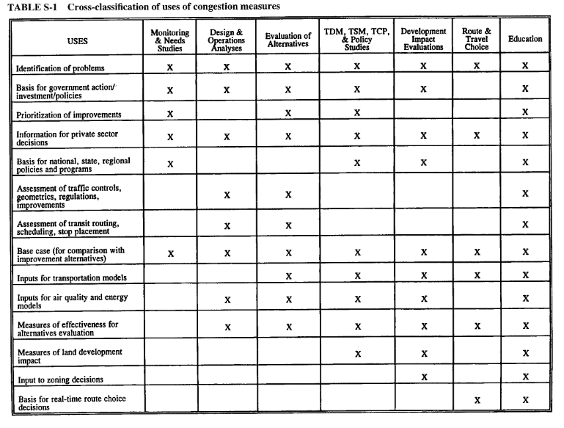

1. Measure of congestion costs using google maps

(Akbar & Duranton, 2017)

1. USING GPS

(Arth, Ohnston, & Adi, n.d.; Barthelemy, 2016; Martin & Thornton, 2017; Pattara-atikom, Pongpaibool, & Thajchayapong, 2006)

1. Importance for Cost-Benefit analysis

(Peer, Koopmans, & Verhoef, 2012)

1. The following capabilities are needed for an ideal approach:

1. Incorporation of the approximate nature of observation and imprecise data, 2. Incorporation of the approximate feeling of a traveler’s acceptable quality of service, and 3. Aggregation of different measured quantities to yield a composite measure. It is believed that a fuzzy inference system could fulfill most of these requirements.

(Hamad & Kikuchi, 2002)

# Methodology and data sets?

|  |  |
| --- | --- |
| Lisbon (center = 1kmN1946E2665, width = 7250)  120 centroids  14400 routes  28800 total requests | Goteborg (center = 1kmN3846E4438, width = 6500)  123 centroids  15129 routes  30258 total requests |
| Glasgow (center = 1kmN3727E3434, width = 6500)  136 centroids  18496 routes  36992 total requests | Lisbon (center = 1kmN1946E2665, width = 6500)  131 centroids  17161 routes  34212 total requests |

Total requests => 36992 + 34212 + 28800 + 30258 = 130262 (+28560)

Cost 10U$D per 1000 => 130262/1000*10 = 1300 aprox (+290 for Lisbon)

# Bibliography

Acheampong, R. A., & Silva, E. A. (2015). Land use–transport interaction modeling: A review of the literature and future research directions. *Journal of Transport and Land Use*, *8*(3), 11–38. https://doi.org/10.5198/jtlu.2015.806

Aftabuzzaman, M. (2007). Measuring Traffic Congestion- A Critical Review. *30th Australasian Transport Research Forum*, 1–16.

Aftabuzzaman, M., Currie, G., & Sarvi, M. (2010). Modeling the spatial impacts of public transport on traffic congestion relief in Melbourne, Australia. *Transportation Research Record*, (2144), 1–10. https://doi.org/10.3141/2144-01

Akbar, P. A., & Duranton, G. (2017). *Measuring the Cost of Congestion in Highly Congested City: Bogotá*. https://doi.org/10.1088/0004-637X/749/2/171

Anas, A., & Rhee, H. (2007). *When are urban growth boundaries not second-best policies to congestion tolls ? ✩*. *61*, 263–286. https://doi.org/10.1016/j.jue.2006.09.004

Andersson, D., & Nässén, J. (2016). The Gothenburg congestion charge scheme : A pre – post analysis of commuting behavior and travel satisfaction. *JTRG*, *52*, 82–89. https://doi.org/10.1016/j.jtrangeo.2016.02.014

Arth, M. A. J. B., Ohnston, E. R. I. C. J., & Adi, R. A. R. T. (n.d.). *Using GPS Technology to Relate Macroscopic and Microscopic Traffic Parameters*. 89–96.

Barthelemy, M. (2016). A global take on congestion in urban areas. *Environment and Planning B: Planning and Design*, *43*(5), 800–804. https://doi.org/10.1177/0265813516649955

Bertini, R. L. (2005). You are the Traffic Jam: An examination of congestion measures. *85th Annual Meetinf of the Transportation Research Board*, (January), 17. https://doi.org/10.1017/CBO9781107415324.004

Bilbao-ubillos, J. (2008). *The costs of urban congestion : Estimation of welfare losses arising from congestion on cross-town link roads*. *42*, 1098–1108. https://doi.org/10.1016/j.tra.2008.03.015

Boisjoly, G., & El-geneidy, A. M. (2017). *The insider : A planners ’ perspective on accessibility*. *64*(August), 33–43. https://doi.org/10.1016/j.jtrangeo.2017.08.006

Borger, B. De, & Proost, S. (2013). Traffic externalities in cities : The economics of speed bumps , low emission zones and city bypasses. *Journal of Urban Economics*, *76*, 53–70. https://doi.org/10.1016/j.jue.2013.02.004

Brandi, A., Gori, S., Nigro, M., & Petrelli, M. (2014). Development of an integrated transport-land use model for the activities relocation in Urban areas. *Transportation Research Procedia*, *3*(July), 374–383. https://doi.org/10.1016/j.trpro.2014.10.018

Bull, A. (2004). Traffic Congestion - The Problem and How to Deal with it? In *United nations: Economic Commission for latin America and the Caribbean, Deutsche gesellschaft für Technische Zusammenarbelt (GTZ) GmbH*. https://doi.org/10.1017/CBO9781107415324.004

Choi, J., Coughlin, J. F., & Ambrosio, L. D. (2013). *Travel Time and Subjective Well-Being*. (2357), 100–108. https://doi.org/10.3141/2357-12

Cookson, G., & Pishue, B. (2016). INRIX Global Traffic Scorecard. *Inrix Global Traffic Scorecard*, (February), 44. Retrieved from https://media.bizj.us/view/img/10360454/inrix2016trafficscorecarden.pdf

Cruz, P., & Machado, P. (2011). Visualizing the circulatory problems of Lisbon. *ACM SIGGRAPH 2011 Posters, SIGGRAPH’11*, 108785. https://doi.org/10.1145/2037715.2037818

Curl, A., Nelson, J. D., & Anable, J. (2011). Research in Transportation Business & Management Does Accessibility Planning address what matters ? A review of current practice and practitioner perspectives. *RTBM*, *2*, 3–11. https://doi.org/10.1016/j.rtbm.2011.07.001

Diakaki, P., Kotsialos, D., & Wang. (2003). Review of road traffic control strategies. *Proceedings of the IEEE*, *91*(12), 2041–2042. https://doi.org/10.1109/JPROC.2003.819606

Downs, A. (n.d.). *Still stuck on traffic*.

Duranton, G., & Turner, M. A. (2011). The fundamental law of road congestion: Evidence from US cities. *American Economic Review*, *101*(6), 2616–2652. https://doi.org/10.1257/aer.101.6.2616

European Commission. (2001). WHITE PAPER: European transport policy for 2010: time to decide. In *Commission of the European Communities*. https://doi.org/9289403411

Eurostat. (2016). Urban Europe. In *The European Territory*. https://doi.org/10.2785/9112094675

Ewing, R. (1997). Is Los Angeles-Style Sprawl Desirable? *Journal of the American Planning Association*, *63*(1), 107–126. https://doi.org/10.1080/01944369708975728

Falcocchio, J. C., & Levinson, H. S. (2015). *Road Traffic Congestion: A Concise Guide* (R. P. Roess, ed.). https://doi.org/10.1007/978-3-319-15165-6

Gairing, M. (2005). *Selfish Routing with Incomplete Information*. 203–212.

Garrido, N. (2012). Computing the cost of traffic congestion: A microsimulation exercise of the City of Antofagasta, Chile. *Transportation Planning and Technology*, *35*(8), 752–768. https://doi.org/10.1080/03081060.2012.739309

Geroliminis, N., & Sun, J. (2011). Properties of a well-defined macroscopic fundamental diagram for urban traffic. *Transportation Research Part B*, *45*(3), 605–617. https://doi.org/10.1016/j.trb.2010.11.004

Gerritse, M., & Arribas-Bel, D. (2018). Concrete agglomeration benefits: do roads improve urban connections or just attract more people? *Regional Studies*, *52*(8), 1134–1149. https://doi.org/10.1080/00343404.2017.1369023

Glaeser, E. L. (2011). Cities, Productivity, and Quality of Life. *Science*, ***(July), 592–595. https://doi.org/10.1126/science.1209264

Gordon, P., & Richardson, H. W. (1997). Are compact cities a desirable planning goal? *Journal of the American Planning Association*, *63*(1), 95–106. https://doi.org/10.1080/01944369708975727

Halfwerk, W., Holleman, L. J. M., Lessells, C. K. M., & Slabbekoorn, H. (2011). *Negative impact of traffic noise on avian reproductive success*. 210–219. https://doi.org/10.1111/j.1365-2664.2010.01914.x

Hamad, K., & Kikuchi, S. (2002). Developing a Measure of Traffic Congestion. *Transportation Research Record*, *1802*(02–2770), 77–85.

Hennessy, D. A., & Wiesenthal, D. L. (1999). *Traffic Congestion , Driver Stress , and Driver Aggression*. *25*(November 1998), 409–423.

HERE. (2019). *The good collaboration guide*.

Hymel, K. M., Small, K. A., & Dender, K. Van. (2010). Induced demand and rebound effects in road transport. *Transportation Research Part B*, *44*(10), 1220–1241. https://doi.org/10.1016/j.trb.2010.02.007

Hysing, E., Frändberg, L., & Vilhelmson, B. (2015). Compromising sustainable mobility? The case of the Gothenburg congestion tax. *Journal of Environmental Planning and Management*, *58*(6), 1058–1075. https://doi.org/10.1080/09640568.2014.912615

Joe Cortright, I. and Ceo. for. (2010). Measuring transportation performance. In *Transportation Quarterly* (Vol. 49). Retrieved from www.ceosforcities.org/work

Jones, P., & Hervik, A. (1992). *RESTRAINING CAR TRAFFIC IN EUROPEAN CITIES : AN EMERGING ROLE FOR ROAD PRICING*. *26*(2), 133–145.

Kansas City Scout. (2011). *2011 Kansa City Scout Congestion Index Report*. Retrieved from http://www.kcscout.net/downloads/Announcements/CongestionReport.pdf

Kelly, F. J., & Zhu, T. (2016). Transport solutions for cleaner air. *Science*, *352*(6288), 934–936. https://doi.org/10.1126/science.aaf3420

Koopmans, C., Groot, W., Warffemius, P., Anne, J., & Hoogendoorn-lanser, S. (2013). Measuring generalised transport costs as an indicator of accessibility changes over time. *Transport Policy*, *29*, 154–159. https://doi.org/10.1016/j.tranpol.2013.05.005

Levinson, H. S., & Lomax, T. J. (1997). Developing a travel time congestion index. *Transportation Research Record*, (1564), 1–10. https://doi.org/10.1177/0361198196156400101

Li, L., Chen, L., Huang, X., & Huang, J. (2008). A traffic congestion estimation approach from video using time-spatial imagery. *Proceedings - The 1st International Conference on Intelligent Networks and Intelligent Systems, ICINIS 2008*, 465–469. https://doi.org/10.1109/ICINIS.2008.182

Litman, T. (n.d.). *Transportation Cost and Benefit Analysis II – Congestion Costs*. (August 2011), 1–24.

Litman, T. (2003). Measuring transportation: Traffic, mobility and accessibility. *ITE Journal (Institute of Transportation Engineers)*, *73*(10), 28–32.

Lomax, T. J. (1997). *Quantifying Congestion Volume 1 - Final Report*. Retrieved from http://worldcat.org/isbn/0309060710

Martin, L. A., & Thornton, S. (2017). Can Road Charges Alleviate Congestion? *SSRN Electronic Journal*, (October 2016). https://doi.org/10.2139/ssrn.3055522

Mehran, B., & Nakamura, H. (2009). *Implementing Travel Time Reliability for Evaluation of Congestion Relief Schemes TRAVEL TIME RELIABILITY AND*. 137–147. https://doi.org/10.3141/2124-13

Miller, E. J., & Salvini, P. A. (2001). The Integrated Land Use, Transportation, Environment (ILUTE) Microsimulation Modelling System. *Travel Behaviour Research*, (January), 711–724. https://doi.org/10.1016/b978-008043924-2/50040-7

Muhammad Ali, P. J., & Faraj, R. H. (2013). *A traffic congestion problem and solutions: the road between Sawz Square and Shahidan Square in Koya city as a case study*. (September 2014), 125–133. https://doi.org/10.2495/isud130151

Nugmanova, A., Arndt, W. H., Hossain, M. A., & Kim, J. R. (2019). Effectiveness of ring roads in reducing traffic congestion in cities for long run: Big Almaty ring road case study. *Sustainability (Switzerland)*, *11*(18). https://doi.org/10.3390/su11184973

Pattara-Atikom, W., & Peachavanish, R. (2007). Estimating road traffic congestion from cell dwell time using neural network. *ITST 2007 - 7th International Conference on Intelligent Transport Systems Telecommunications, Proceedings*, 12–17. https://doi.org/10.1109/ITST.2007.4295824

Pattara-atikom, W., Pongpaibool, P., & Thajchayapong, S. (2006). Estimating road traffic congestion using vehicle velocity. *ITST 2006 - 2006 6th International Conference on ITS Telecommunications, Proceedings*, 1001–1004. https://doi.org/10.1109/ITST.2006.288722

Peer, S., Koopmans, C. C., & Verhoef, E. T. (2012). Prediction of travel time variability for cost-benefit analysis. *Transportation Research Part A*, *46*(1), 79–90. https://doi.org/10.1016/j.tra.2011.09.016

Percoco, M. (2014). The effect of road pricing on traffic composition: Evidence from a natural experiment in Milan, Italy. *Transport Policy*, *31*(January 2012), 55–60. https://doi.org/10.1016/j.tranpol.2013.12.001

Pongpaibool, P., Tangamchit, P., & Noodwong, K. (2007). Evaluation of road traffic congestion using fuzzy techniques. *IEEE Region 10 Annual International Conference, Proceedings/TENCON*, 1–4. https://doi.org/10.1109/TENCON.2007.4429119

Porikli, F., & Li, X. (2004). Traffic congestion estimation using HMM models without vehicle tracking. *IEEE Intelligent Vehicles Symposium, Proceedings*, 188–193. https://doi.org/10.1109/ivs.2004.1336379

Quddus, M. A., Wang, C., & Ison, S. G. (2010). *Road Traffic Congestion and Crash Severity : Econometric Analysis Using Ordered Response Models*. *136*(May), 424–435.

Reed, T., & Kidd, J. (2019). Global Traffic Scorecard. *INRIX Research*, *1*(February), 16. https://doi.org/10.1163/156854108783360159

Rempe, F., Huber, G., & Bogenberger, K. (2016). Spatio-Temporal Congestion Patterns in Urban Traffic Networks. *Transportation Research Procedia*, *15*, 513–524. https://doi.org/10.1016/j.trpro.2016.06.043

Rouwendal, J., Verhoef, E. T., & Knockaert, J. (2012). Give or take? Rewards versus charges for a congested bottleneck. *Regional Science and Urban Economics*, *42*(1–2), 166–176. https://doi.org/10.1016/j.regsciurbeco.2011.08.011

Safirova, E., Gillingham, K., & Houde, S. (2007). Measuring marginal congestion costs of urban transportation: Do networks matter? *Transportation Research Part A: Policy and Practice*, *41*(8), 734–749. https://doi.org/10.1016/j.tra.2006.12.002

Santos, G., Behrendt, H., & Teytelboym, A. (2010). Research in Transportation Economics Part II : Policy instruments for sustainable road transport q. *Research in Transportation Economics*, *28*(1), 46–91. https://doi.org/10.1016/j.retrec.2010.03.002

Skabardonis, A., Varaiya, P., & Petty, K. F. (2003). Measuring Recurrent and Nonrecurrent Traffic Congestion. *Transportation Research Record*, (1856), 118–124. https://doi.org/10.3141/1856-12

Soylemezgiller, F., Kuscu, M., & Kilinc, D. (2013). A traffic congestion avoidance algorithm with dynamic road pricing for smart cities. *IEEE International Symposium on Personal, Indoor and Mobile Radio Communications, PIMRC*, 2571–2575. https://doi.org/10.1109/PIMRC.2013.6666580

Stempfel, J., Guler, S. I., Menéndez, M., & Brucks, W. M. (2016). Effects of urban congestion on safety of networks. *Journal of Transportation Safety and Security*, *8*(3), 214–229. https://doi.org/10.1080/19439962.2015.1007193

Stopher, P. R. (2006). *Reducing road congestion : a reality check*. *11*(2004), 117–131. https://doi.org/10.1016/j.tranpol.2003.09.002

Sultana, S. (2013). *Job / Housing Imbalance and Commuting Time in the Atlanta Metropolitan Area : Exploration of Causes of Longer Commuting Time*. *3638*(May). https://doi.org/10.2747/0272-3638.23.8.728

Sutton, J. C. (2015). *Gridlock*. https://doi.org/10.4324/9781315723846

Sweet, M. (2011). Does traffic congestion slow the economy? *Journal of Planning Literature*, *26*(4), 391–404. https://doi.org/10.1177/0885412211409754

The Texas A&M Transportation Institute. (2019). *Urban Mobility Report*.

Tom Tom. (2012). Tomtom European Congestion Index. In *Tomtom*. Retrieved from http://www.tomtom.com/lib/doc/congestionindex/2012-1003-TomTom-Congestion-Index-2012-Q2-europe-mi.pdf

TomTom. (2019). TomTom Traffic Index: Mumbai takes Crown of ‘Most Traffic Congested City’ in World. *TomTom Traffic Index*, 1–4. Retrieved from https://library.tomtom.com/share/0E286C8F-F2E0-4422-923E8D1B7C5F2B61/?mediaId=4C386BE9-E2B0-4691-99440A38CAD754A3%0Ahttp://corporate.tomtom.com/releasedetail.cfm?releaseid=961546

Tsekeris, T., & Vogiatzoglou, K. (2011). Spatial agent-based modeling of household and firm location with endogenous transport costs. *NETNOMICS: Economic Research and Electronic Networking*, *12*(2), 77–98. https://doi.org/10.1007/s11066-011-9060-y

Vandenbulcke, G., Steenberghen, T., & Thomas, I. (2012). Mapping accessibility in Belgium : a tool for land-use and transport planning ? *Journal of Transport Geography*, *17*(1), 39–53. https://doi.org/10.1016/j.jtrangeo.2008.04.008

Wang, C., Quddus, M. A., & Ison, S. G. (2013). The effect of traffic and road characteristics on road safety: A review and future research direction. *Safety Science*, *57*, 264–275. https://doi.org/10.1016/j.ssci.2013.02.012

Wang, S., He, L., Stenneth, L., Yu, P. S., & Li, Z. (2015). Citywide traffic congestion estimation with social media. *GIS: Proceedings of the ACM International Symposium on Advances in Geographic Information Systems*, *03*-*06*-*Nove*. https://doi.org/10.1145/2820783.2820829

Wardman, M., & Bristow, A. L. (2004). *Traffic related noise and air quality valuations : evidence from stated preference residential choice models*. *9*, 1–27. https://doi.org/10.1016/S1361-9209(03)00042-7

Weisbrod, G., Vary, D., & Treyz, G. (2003). Measuring economic costs of urban traffic congestion to business. *Transportation Research Record*, (1839), 98–106. https://doi.org/10.3141/1839-10